Unit 1: HOME
Period 8 – Reading – Speaking (page 13)

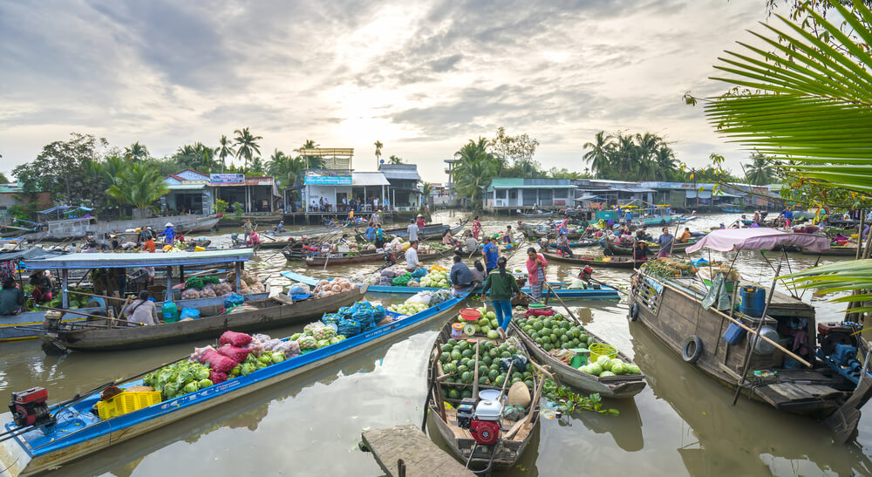
READING: Read the paragraph and answer the questions.
Cần Thơ is a city in the south of Vietnam. It is in the Mekong Delta, on the Hậu River. Many people live in Cần Thơ. It is a big city. Lots of people visit it to see its floating markets and beautiful rivers. The weather is hot. It is very good for growing food. Farmers grow rice, vegetables, and different fruits. It is an important center for business and transportation.
- New words: (ghi vaò tập)
- Floating market (n) /ˈfloʊ.t̬ɪŋ/ /ˈmɑːr.kɪt/ : chợ nổi
- Delta (n) /ˈdel.t̬ə/ : vùng đồng bằng
- Weather (n) /ˈweð.ɚ/ : thời tiết
- Grow (v) /ɡroʊ/ : phát triển
- Farmer (n) /ˈfɑːr.mɚ/ : nông dân
- Important (adj) /ɪmˈpɔːr.tənt/ : quan trọng, trọng yếu
Ex: an important center for ..... : trọng tâm cho việc gì
- Business (n) /ˈbɪz.nɪs/ : kinh doanh, buôn bán
- Transportation (n) /ˌtræn.spɚˈteɪ.ʃən/ : vận tải, sự chuyên chở
- Region /ˈriː.dʒən/ : vùng miền
- Population /ˌpɑː.pjəˈleɪ.ʃən/ : dân số, dân cư
- Average temperature (n) /ˈæv.ɚ.ɪdʒ/ /ˈtem.pɚ.ə.tʃɚ/ : nhiệt độ trung bình

- Exercise 1: Students read the passage about the floating markets in Cần Thơ and answer the questions: ( ghi vào tập)
- Where is Cần Thơ?
....................................................................................................................
- What is it famous for?
.....................................................................................................................
- What is the weather like?
.....................................................................................................................
- What do the farmers grow?
.....................................................................................................................
- Exercise 2: From the passage, rewrite the sentences that summarize about Cần Thơ: ( ghi vào tập)
- Cần Thơ / south of / Vietnam.
........................................................................................................................
- It / big / city.
.........................................................................................................................
- There / floating markets / beautiful / rivers.
.........................................................................................................................
- The hot / weather / good / food.
.........................................................................................................................
- The farmers / a lot of / rice / and / fruits.
.........................................................................................................................
- It / important / transportation.
.........................................................................................................................
SPEAKING: What Do You Know about These Places?
- You’re planning a geography presentation. Work in pairs. Student A, answer Student B’s questions about Colmar. Swap roles and repeat with Clovelly. .
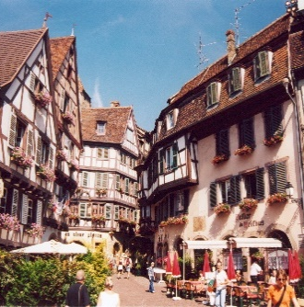  COLMAR | - East of France  - Big town  - famous for beautiful houses museums famous for old houses and fishing  - Warm | 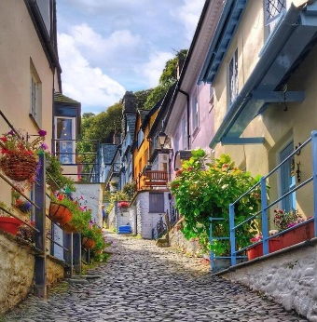  CLOVELLY | - South of England  - Small village  - Famous for old houses and fishing  - Cold

Ex: Student A: Where is Colmar? Ex: Student B: Where is Clovelly?
Student B: It is in the east of France. Student A: It is in the south of England.
...................... .........................

- Ask and answer about other places that you know.
- Suggestions:
Vung Tau Beach  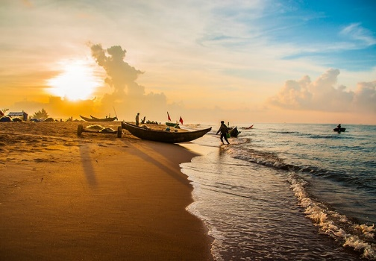 | Da Lat City  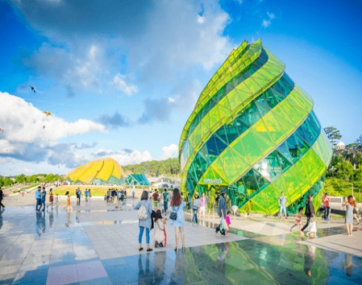 | Singapore  